YOLOP: You Only Look Once for Panoptic Driving Perception
Dong Wu, et al.

- Source: https://arxiv.org/pdf/2108.11250.pdf

- Performs traffic object detection, drivable area segmentation (DAS), and lane-line segmentation (LLS).
- Compose of one encoder for feature extraction and three decoders.
- State-of-the-art results on BDD100k
- Real-time: 23 FPS on Jetson TX2

- High-precision and real-time are two most critical requirements for autonomous driving.

- Models for specific tasks:
  - RCNN and YOLO series – object detection
  - ENet and PSPNet – semantic segmentation
  - SCNN and SAD-Enet – lane detection

- Using different model for each task means longer time and thus not real-time. Moreover, you have limited computational resources on vehicles.

- Tasks in autonomous driving are related:
  - lanes are often the boundary of drivable area
  - drivable area usually closely surrounds the traffic objects.
- Thus, a multi-task network is more suitable.

- Single-stage detection networks (e.g. YOLO) are faster compared to the two-stage networks. Also, the grid-based approach in single-stage detection is more related to semantic segmentation (based on author’s experiments).

- End-to-end training (meaning training the whole network in one stage) works good enough as compared to alternating optimization (meaning training the network one task after the other).

- Backbone:
  - CSPDarknet (used in YOLOv4) to extract features
- Neck:
  - SPP and FPN modules
  - SPP generates and fuses features of different scales, and FPN fuses features at different semantic levels, making the generated features contain multiple scales and multiple semantic level information.
- Detection Head:
  - anchor-based multi-scale detection similar to YOLOv4
  - First, PAN – a bottom-up feature pyramid network
  - Then, PAN’s conv feature maps for detections at 3 different scales
  - 3 anchors per scale

- FPN – transfers semantic information top-down
- PAN – transfers positioning information bottom-up

- Drivable area and Lane Line Segment Heads:
  - Same network structure for both heads
  - Output of the lowest level of FPN to the heads; shape (W/8, H/8, 256) if W and H are input image dimensions
  - Three upsampling; Nearest Interpolation method
  - Head output shape: (W, H, 2)
  - 2 channels in output because we have two classes: drivable area and non-drivable area in one head; and lane-line and non-lane-line in the other head

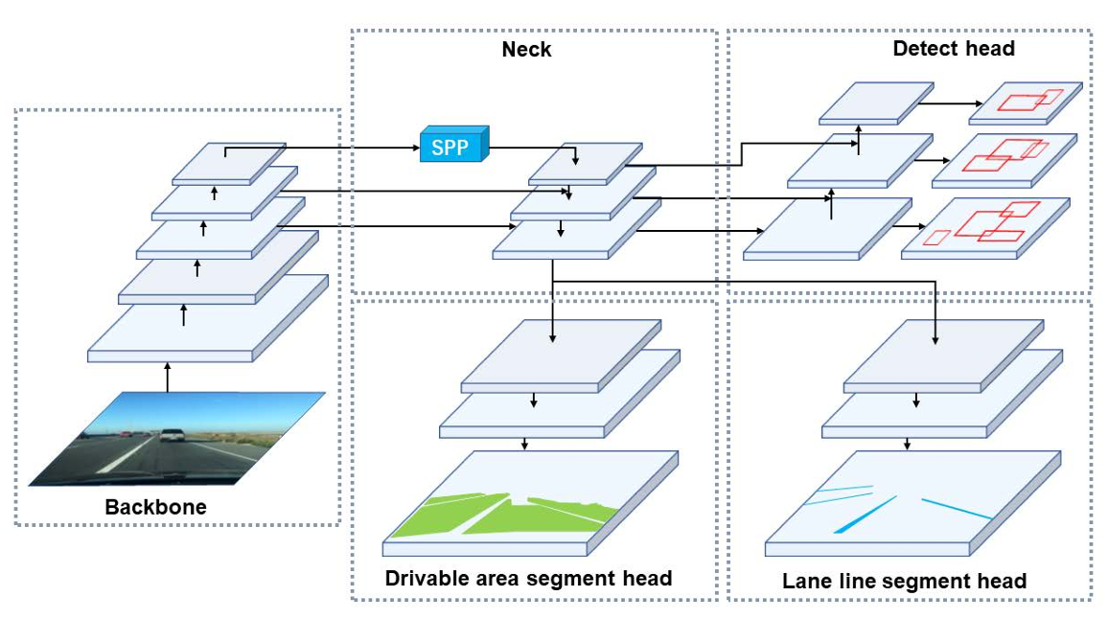

- Loss Function:
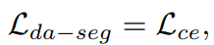
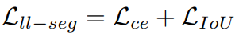

$L_{class}$ and $L_{obj}$ are focal loss. The first one is for classification and the second is for object detection confidence.
$L_{box}$ is $L_{CIoU}$, i.e. Complete IoU.
$L_{ce}$ is cross-entropy loss with logits.
$L_{IoU}=1-\frac{TP}{TP+FP+FN}$

- $α_{1}, α_{2}, α_{3}, γ_{1}, γ_{2}, γ_{3}$ are hyper-parameters that need to be tuned.

- BDD100K:
  - For autonomous driving
  - Diversity of geography, weather, environment, lighting conditions (morning, noon, night, etc.)
  - 10 classes
  - 70k training images
  - 10k validation images
  - 20k testing images (not publicly available)

- K-means to find anchors
- Adam optimizer; $β_{1}=0.937$, $β_{2}=0.999$
- Initial learning rate: 0.01
- Warm-up
- Cosine-annealing
- Data Augmentation: HSV distortions, random rotating, scaling, translating, shearing, left-right flipping
- Input images: resized from 1280*720 to 640*384

